Unit 6 Hands-On Projects
Code Explanation and Testing Summary
Ariel Garcia Delgado
Miami Dade College
COP2800 Java Programming
Dr. Martins Idahosa
June 27, 2026
This document explains the completed Java programs for the Unit 6 Hands-On Projects. Each project was implemented from the provided starter file by replacing the TODO sections with working code, using Scanner input, methods, classes, objects, branching, loops, and standard Java libraries where appropriate.

Project Summary
Project | File | Main concept | Completed features
1 | MinutesConversion.java | Methods and numeric conversion | Reads minutes, validates input, converts minutes to hours and days, and prints formatted output.
2 | TrafficLight.java | Class, attributes, and methods | Stores color and duration, changes color, checks red/green status, and prints object state.
3 | Employee.java | Class with date handling | Stores name, salary, hire date, and calculates years of service with LocalDate and Period.
4 | Student.java | Class with ArrayList and menu loop | Stores name, grade, and course list; adds, removes, lists courses, and exits through a menu.

Project 1: MinutesConversion.java
This program accepts an integer number of minutes from the user and converts the value into hours and days. The code uses separate methods to keep the conversion logic organized and easier to test.

Implementation Logic
- The program imports Scanner for keyboard input and DecimalFormat for clean numeric output.
- convertToHours(int minutes) divides the minutes by 60.0 so the result is a double instead of integer division.
- convertToDays(int minutes) divides the minutes by 1440.0 because one day has 24 hours and each hour has 60 minutes.
- buildOutput(int minutes, double hours, double days) creates the final sentence using DecimalFormat so values such as 100.0 can display cleanly as 100.
- The main method prompts for minutes, validates that the value is not negative, calls the conversion methods, and prints the final formatted result.

Sample Test
Input: 6000
Output: 6000 minutes equals 100 hours and equals 4.167 days.

Project 2: TrafficLight.java
This program creates a TrafficLight class with color and duration attributes. It demonstrates how an object can store state and how methods can update and check that state.

Implementation Logic
- The class declares private instance variables color and duration.
- The constructor accepts the starting color and duration and stores the color in uppercase to make comparisons consistent.
- changeColor(String newColor) updates the color attribute.
- isRed() returns true only when the current color equals RED.
- isGreen() returns true only when the current color equals GREEN.
- toString() returns a readable description of the traffic light object.
- The main method creates a red traffic light, prompts the user for two color changes, and prints the red/green checks after each change.

Sample Test
Input: GREEN, YELLOW
Output: RED starts as red, GREEN returns true for isGreen(), and YELLOW returns false for both isRed() and isGreen().

Project 3: Employee.java
This program creates an Employee class with name, salary, and hire date attributes. It calculates years of service using Java date classes.

Implementation Logic
- The class imports LocalDate and Period from java.time.
- The constructor stores the employee name, salary, and hire date.
- getYearsOfService() uses Period.between(hireDate, LocalDate.now()).getYears() to calculate full years between the hire date and today.
- toString() formats the employee information, including salary with two decimal places.
- The main method prompts for employee data, parses the hire date in YYYY-MM-DD format, creates an Employee object, and prints the employee and years of service.

Sample Test
Input: Alex, 60000, 2018-06-15
Output: The program displays the employee information and the calculated years of service.

Project 4: Student.java
This program creates a Student class with name, grade, and an ArrayList of courses. It uses a menu loop so the user can add, remove, and list courses until choosing to exit.

Implementation Logic
- The class imports ArrayList to store a flexible list of course names.
- The constructor stores the student name and grade and creates an empty course list.
- addCourse(String course) appends a course to the ArrayList and confirms the action.
- removeCourse(String course) attempts to remove the course and prints whether the course was found.
- listCourses() prints all courses, or a message if no courses are currently listed.
- The main method asks for student information and uses a do-while loop to keep showing the menu until the user selects Exit.

Sample Test
Input: Add Java Programming, add Data Structures, list, remove Java Programming, list, exit.
Output: The program shows both courses, removes Java Programming, then shows only Data Structures.

Testing Summary
The completed Java files were compiled successfully with javac. Each program was also run with sample input to confirm that the output matches the intended behavior. The following table lists suggested screenshots to include in the Canvas submission.
Program | Screenshot of code | Screenshot of output
MinutesConversion.java | Capture the complete Java file open in IntelliJ IDEA. | Run the program with the suggested test input and capture the console output.
TrafficLight.java | Capture the complete Java file open in IntelliJ IDEA. | Run the program with the suggested test input and capture the console output.
Employee.java | Capture the complete Java file open in IntelliJ IDEA. | Run the program with the suggested test input and capture the console output.
Student.java | Capture the complete Java file open in IntelliJ IDEA. | Run the program with the suggested test input and capture the console output.

Reflection
These projects helped me practice breaking a program into smaller methods and designing classes with attributes and behaviors. MinutesConversion focused on numeric conversion and formatted output. TrafficLight, Employee, and Student focused on object-oriented programming, including constructors, instance variables, methods, and object state. The Student project also added practice with ArrayList and menu-based user interaction. One important point I noticed is that separating logic into methods makes the code easier to test and explain.
A question I would ask after completing this assignment is how much validation should be added for real-world programs, such as preventing invalid colors in TrafficLight, invalid dates in Employee, or duplicate courses in Student.

Screenshots Evidence from IntelliJ IDEA
The following screenshots are real IntelliJ IDEA screenshots showing the working source code and accurate program output for each Unit 6 Hands-On Project. These screenshots support the implementation and testing requirements in the assignment rubric.

Figure 1. Project 1 - MinutesConversion Output
Shows the program converting 9000 minutes into 150 hours and 6.25 days.
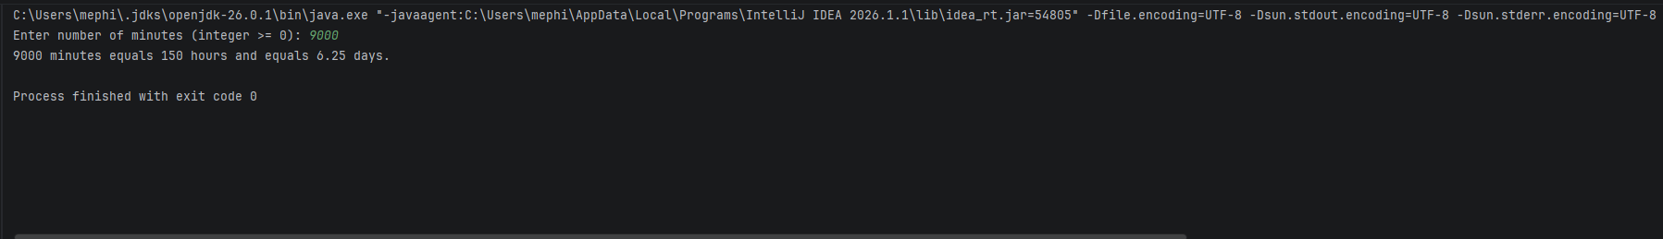

Figure 2. Project 1 - MinutesConversion Code
Shows the completed MinutesConversion.java source code with methods and input validation.
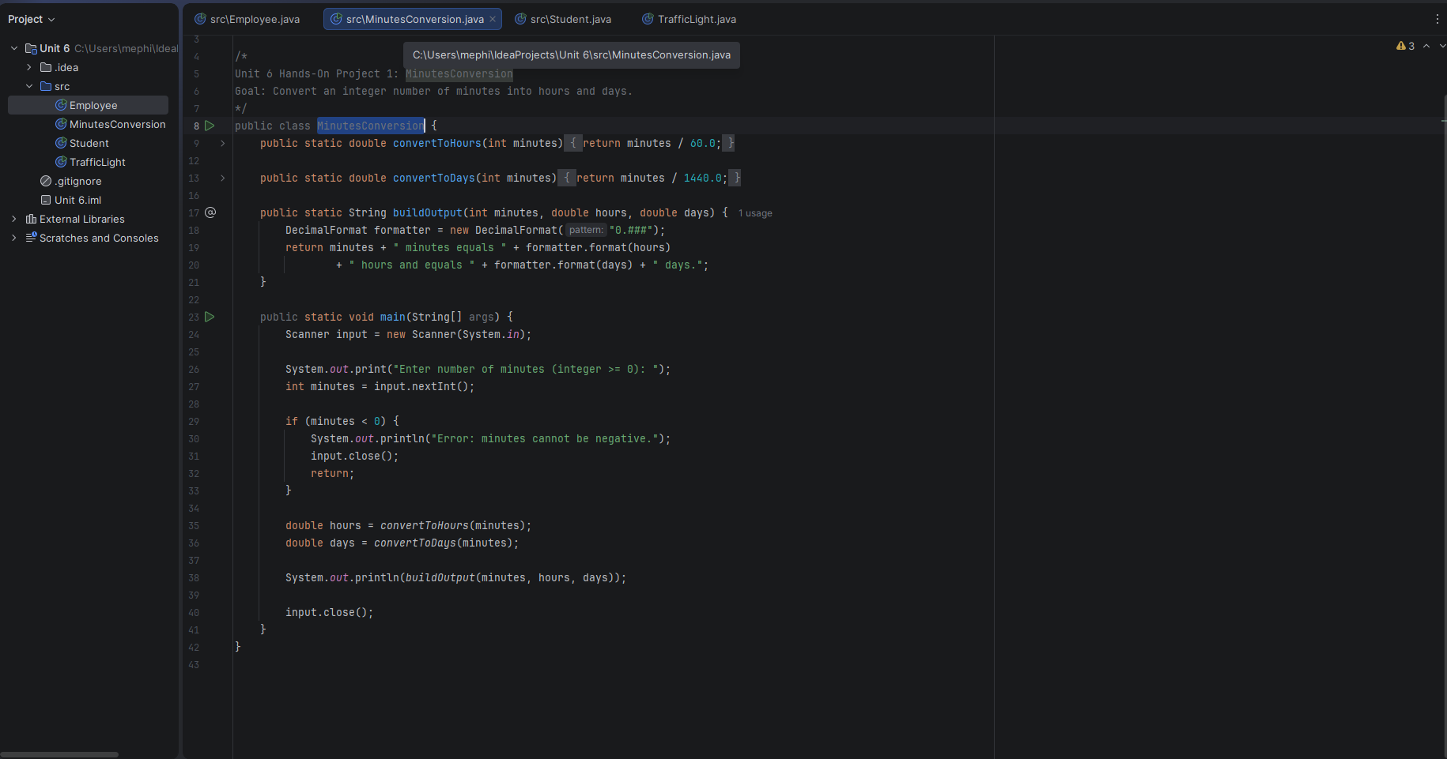

Figure 3. Project 2 - TrafficLight Output
Shows color changes from RED to GREEN to YELLOW and the isRed/isGreen checks.
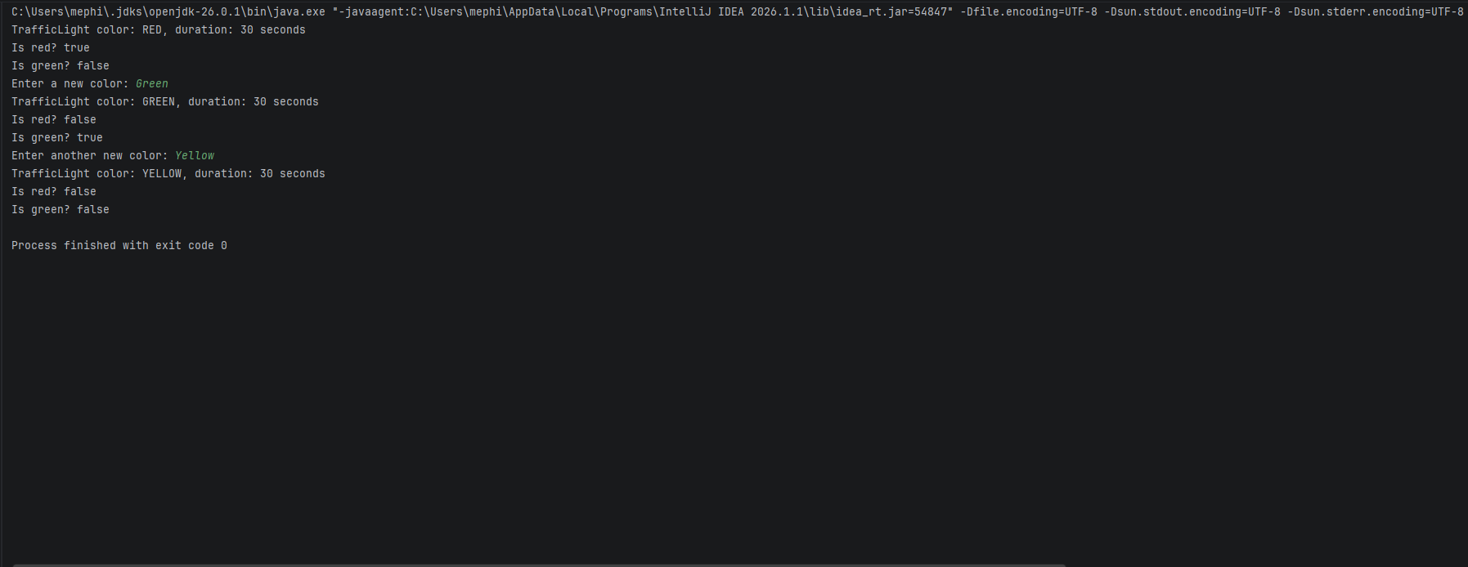

Figure 4. Project 2 - TrafficLight Code
Shows the completed TrafficLight.java class with attributes, constructor, methods, and main test flow.
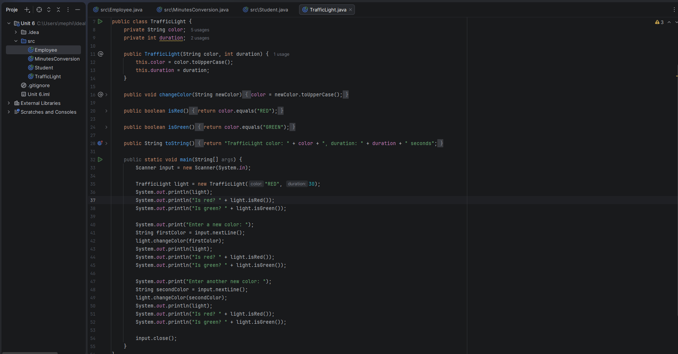

Figure 5. Project 3 - Employee Output
Shows employee input, formatted employee information, and calculated years of service.
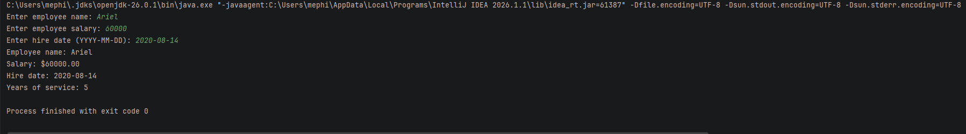

Figure 6. Project 3 - Employee Code
Shows the completed Employee.java class using LocalDate and Period.
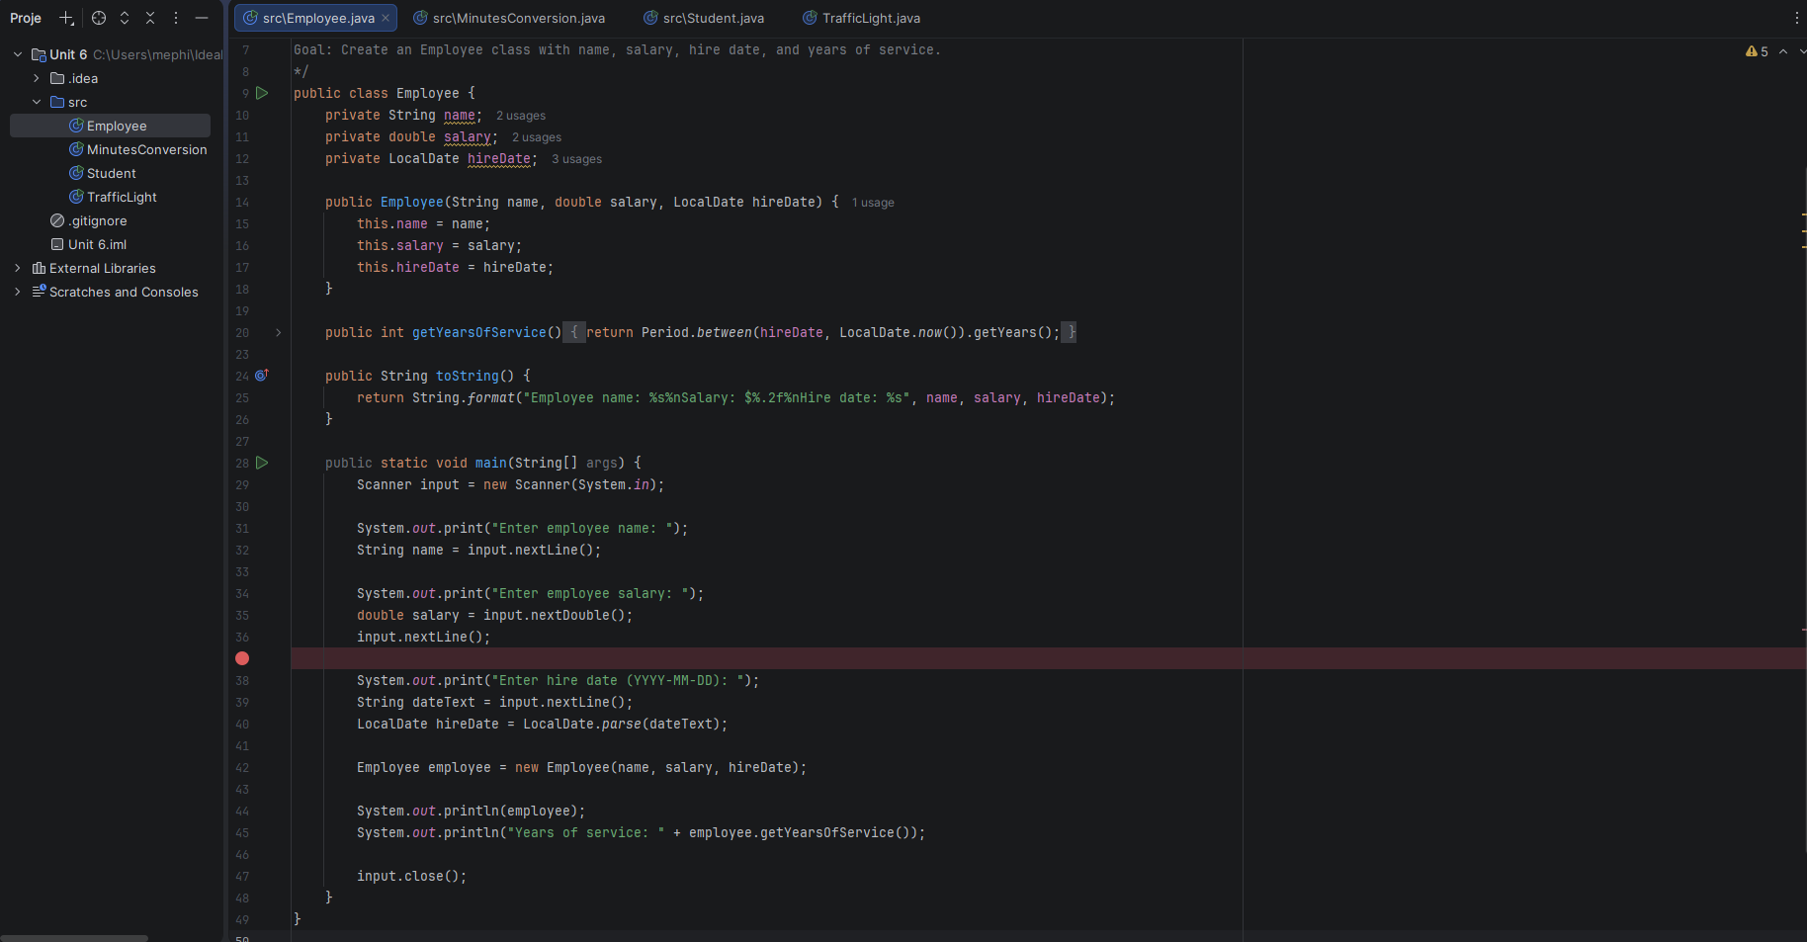

Figure 7. Project 4 - Student Output
Shows the menu loop, adding courses, removing a course, listing courses, and exiting.
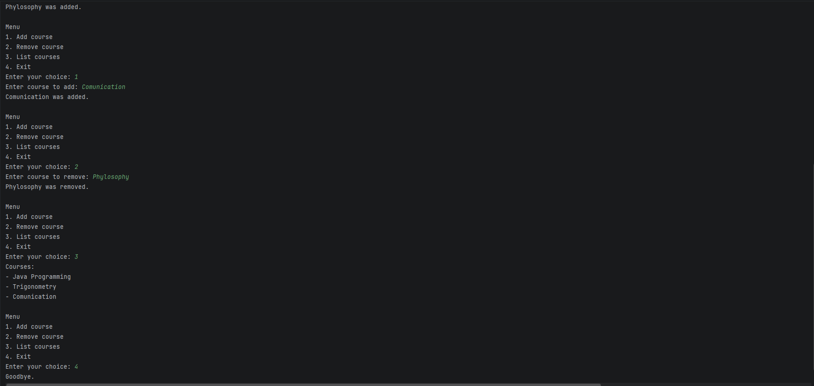

Figure 8. Project 4 - Student Code
Shows the completed Student.java class with ArrayList course management and menu logic.
